Student Name
Student Number
Subject

- 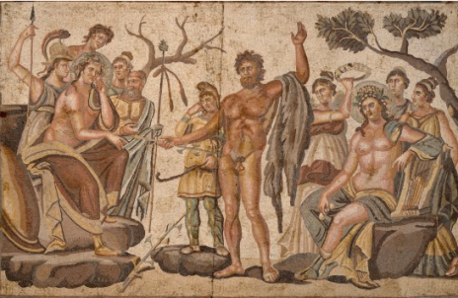 2. 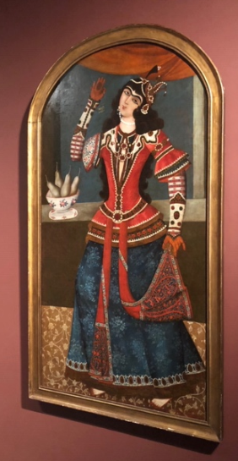

Title: 1. Mosaic Panels, The Musical Contest between Apollo and Marsyas 2. Dancing girl
Artist: 1. Roman 2. Muhammad Baqir
Date: 1. 100-300AD 2. 1192 AH
Medium: Stone and glass mosic 2. Oil Painting
Region: Greek 2. Persia

Cultural Contest

Is a representation of historical mythology event of Roman and Greek. The illustration represents an event where Apollo is being crowned for defeating Marsyas in a dancing contest. It also represents characters such as Gods such as the god of wine, Dionysus, Athena the goddess who came up with a flute, and who judged the contest and Nike the goddess of victory as well as Muses the goddess of arts were judges during the contest, standing behind Apollo.

Muhammad Baqirs’s work is, on the other hand, a decorative representing Muslim stylistic female dancer. The fashionable representation of the dancer is an indication of a point of intersection between the Western and Eastern cultures. This illustration is an ideal presentation of Persian arts.

Style

While Roman’s work focuses on men in the presentation of Greek culture and beauty of dance, Baqir’s work represents the beauty of dance and the culture through a woman. That shows the differences in the roles played by both genders in their time.

Technique

Baqir utilizes oil paintings as a mode of her work. On the other hand, Roman’s work is made as a mosaic made of stones and glass.

While both the artworks represent two stories revolving around dance, Roman’s work focuses on men in the presentation of Greek culture and beauty of dance while Baqir’s work represents the beauty of dance and the culture through a woman. That shows the differences in the roles played by both genders in their time.

Iconography

Baqir’s work is a painting made of oil canvas, Roman’s work, on the other hand, is a mosaic of stone and glass. Baqir’s work is made for the purpose of presenting a decorative work depicting the ideal beauty of the Persian culture.

Roman’s work, Apollo is seated on the right side and is presented as a victorious character. His posture depicts a relaxing mood while the tree behind him blossoms with thick leaves depicting history. Marsyas who stands at the center represents a d defeat. His posture shows that he has been defeated and miserable. This illustration sets two contrasting moods, a cerebrating mood on the side of Apollo and a mourning mood on the other side, where Marsyas stands at the center of the two sides. Thee leafless and dying tree on Marsya's side depicts his miserable fate.

Composition

Baqir’s artwork represents well-arranged visual elements in that the character properly fits in the frame in a dancing posture. The character’s upper body is placed to fit exactly at the center of the open window behind her, drawing our attention to her head, face, chest ad her raised arm.

Roman’s work also presents a proper arrangement of elements, for instance, the characters are arranged in two groups separated by one character at the center. There is one tree on each of the sides

Balance

In Roman’s work, the characters are well arranged to create a balance between both sides. The arrangement presents a symmetrical arrangement because both sides have equal number of characters and another character is placed at the center to connect both sides.

Baqir’s on the other hand presents the body of the woman in an asymmetrical posture in that she does not have a strait posture while she has one arm lifted while the other one is down. Her knees are also bent and her head tilted to one side, opposite the body lean.

Contrast

Roman’s work utilizes the aspect of color in a perfect way to represent a naturalistic environment of the event. The color differentiates the dressing between the characters and their dressing as well as differentiating them with the natural features such as trees and stones. For instance, brown color has been used on peoples skins, grey on the stones and trees as well as green on tree leaves. The sizes have been used to direct focus on important characters on the drawing. The most important characters appear bigger than the rest of the characters.

On Baqir’s illustration, different colors have been used to create attention catching patterns on the characters dressing. The character is also represented in a big size to create emphasis on her dressing as well as the patterns on her clothes.

In conclusion, while these two artworks represent differences in terms of the story, the purpose, and materials that have been used to make them, they also share the similarity that they represent stories that revolve around music and dance.

